

Foundations of Programming
Assignment No. : 11

PROBLEM STATEMENT:
Write a program in C to accept a number from the user and compute the following:
- Square root of the number
- Square of the number
- Cube of the number
- Check whether the number is prime
- Factorial of the number
- Prime factors of the number

OBJECTIVE:
• To understand the use of mathematical operations in C.
• To implement loops and conditional statements
. • To perform number-based computations.
• To enhance logical thinking using menu-driven programs.

THEORY:
Numbers and their mathematical properties play a vital role in programming. Operations such as square, cube, and square root are basic mathematical computations. Prime number checking involves verifying whether a number has exactly two divisors. Factorial is calculated by multiplying a sequence of integers. Prime factorization breaks a number into its prime components. In C programming, these operations can be efficiently implemented using loops, conditional statements, and mathematical functions.

PLATFORM:
Linux

ALGORITHM:
- START
- Display a menu with the following options:
- Square root of a number
- Square of a number
- Cube of a number
- Check whether the number is prime
- Factorial of the number
- Prime factors of the number
- Accept an integer number n from the user.
- Read the user’s choice.
- Use switch–case to perform the selected operation:
- If choice = 1, calculate square root of n.
- If choice = 2, calculate square of n.
- If choice = 3, calculate cube of n.
- If choice = 4, check whether n is prime.
- If choice = 5, calculate factorial of n using a loop.
- If choice = 6, find and display prime factors of n.
- Display the result.
- Ask the user whether to continue.
- If yes, repeat from step 2.
- STOP

C PROGRAM:
#include <stdio.h>
#include <math.h>
int main() {
int n, choice, i, isPrime = 1;
long long fact = 1;

printf("Enter a number: ");
scanf("%d", &n);

printf("\nMenu:\n");
printf("1. Square Root\n");
printf("2. Square\n");
printf("3. Cube\n");
printf("4. Check Prime\n");
printf("5. Factorial\n");
printf("6. Prime Factors\n");

printf("Enter your choice: ");
scanf("%d", &choice);

switch(choice) {

case 1:
if (n >= 0)
printf("Square Root = %.2f", sqrt(n));
else
printf("Square root not defined for negative numbers");
break;

case 2:
printf("Square = %d", n * n);
break;

case 3:
printf("Cube = %d", n * n * n);
break;

case 4:
if (n <= 1)
isPrime = 0;
for (i = 2; i <= n / 2; i++) {
if (n % i == 0) {
isPrime = 0;
break;
}
}
if (isPrime)
printf("Number is Prime");
else
printf("Number is Not Prime");
break;

case 5:
if (n < 0) {
printf("Factorial not defined for negative numbers");
} else {
for (i = 1; i <= n; i++)
fact *= i;
printf("Factorial = %lld", fact);
}
break;

case 6:
printf("Prime Factors: ");
for (i = 2; i <= n; i++) {
while (n % i == 0) {
printf("%d ", i);
n /= i;
}
}
break;
default:
printf("Invalid choice");
}
return 0;
}

INPUT:
The user enters an integer number and selects an operation from the menu.
Example Input: Number: 5 Choice: 3
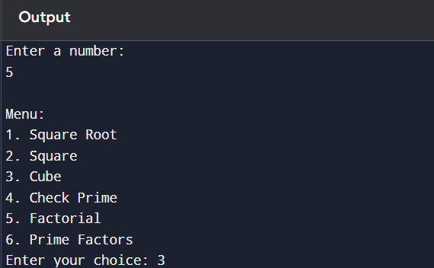

Paste Screen Shot of Input

OUTPUT:
Example Output:
The program displays the result based on the selected operation.
Example Output: Cube = 125
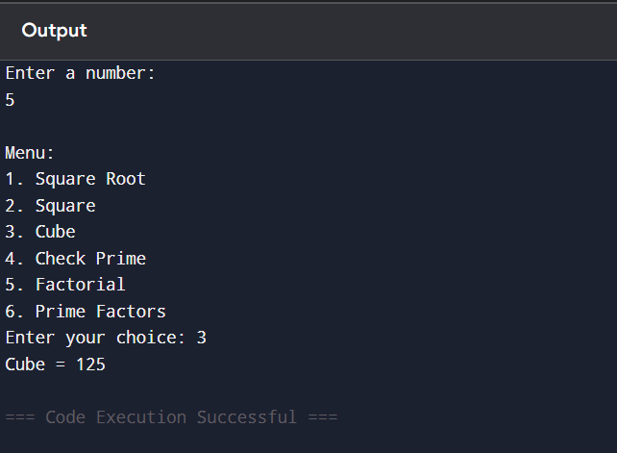
Paste Screen Shot of Output

CONCLUSION:
Thus, the program to perform various mathematical operations on a number was successfully implemented using C programming. This program demonstrates the use of loops, conditional statements, switch-case, and mathematical functions.

FAQs:
- Why is checking divisibility only up to n/2 sufficient in prime number verification, and how can this be optimized further?
- What are the limitations of using int data type for factorial calculation, and how can overflow be handled in C?
- How does the time complexity of prime factorization change with increasing input size?
- Why is the math.h library required for square root calculation, and what happens if it is not included?
- How would the program behaviour change if a negative number is entered for factorial or square root operations?
- Explain the difference between checking a number for primality and generating prime factors of the same number.
- How can recursion be used to calculate factorial instead of loops, and what are its advantages and disadvantages?

